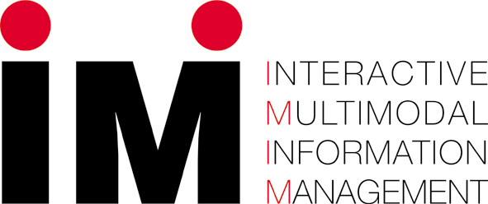

IM2 Call for Project Proposals

Proposer Details
Please note that proposals should come from Switzerland

Title:
Family Name
First Name
Year of Birth
Email
Institution
Position
Contact Address

Scientific Content
Proposal Title

Abstract (max 1000 Characters, approx. 150 words)

Short, but clear and precise!!!
Clear project objectives and progress evaluation measures.
Good integration within IM2.
Key Words (open format, max 400 characters, approx. 50 words)

Preferred IM2 individual project
Relation to IM2 individual project(s)?

Text of proposal (max 10000 characters, approx 1500 words)

Should be clear and precise, clearly addressing the objectives of the project and the progress evaluation measures.

How does your project proposal integrate within IM2?

Background, problems

Benefits to IM2

Objectives, deliverables and expected scientific impact

Scientific Program and innovation

